Customer Table:

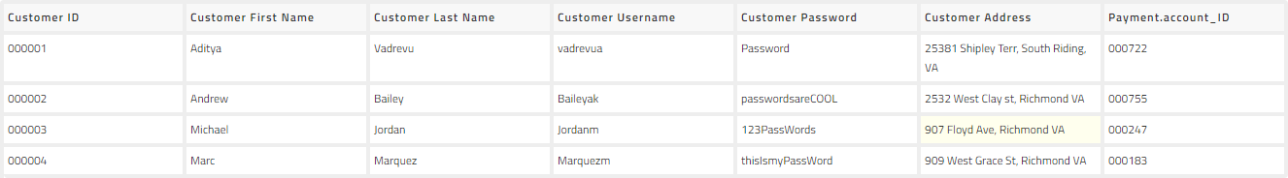

Order Table:

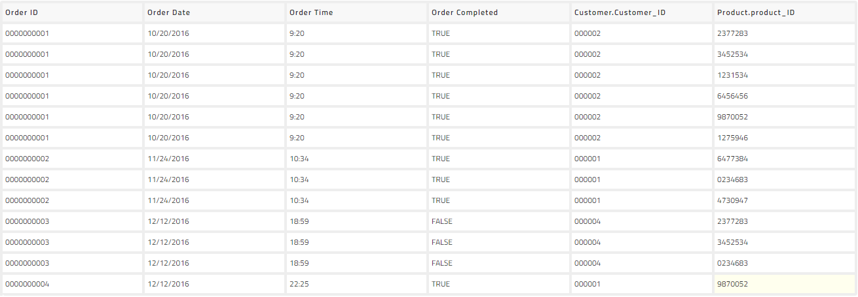

Payment Account Table:

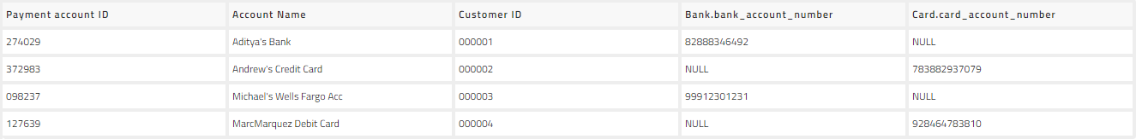

Bank Account Table:



Card Account Table:



Discount Table:



Product Table:

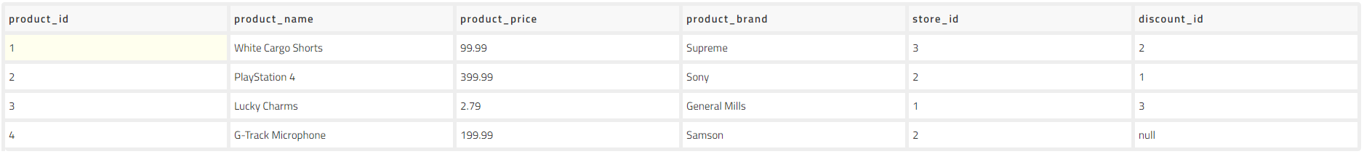

Store Table:

